**Connect to Virtual Machine**

Many labs that teach networking or security skill will rely on tools that are made to be ran from a **Command Line Interface,** or **CLI**. This is also true for the majority of labs performed on GENI infrastructure. However, you may find certain tasks become much easier or are more familiar while using a **Graphical User Interface**, or **GUI**. This tutorial will provide a walkthrough for setting up both CLI and GUI on a machine hosted on the GENI infrastructure.

**Note: All the following screenshots are based on the RSpec file specified on Setup Lab document. You might see a little bit different based on your RSpec file specified on the lab document. Even though the screenshots are different, all the steps will be same as the following instructions.**

**For Windows Machine:**

To provide the GUI on the GENI machine we will be using Putty for SSH connection and using **Virtual Network Computing**, or **VNC** for GUI. Here is an overview of the steps.

**Key steps:**

1. Connect to GENI Machine with Putty.
2. Run VNC on our GENI machine
3. Install a VNC client on our Host machine
4. Connect to the VNC server on the GENI machine.

Let’s begin:

**Step 1: Connect GENI machine with Putty.**

We will assume that the student will already have a machine up and running in the GENI environment. We also assume the student will be able to find the URI used to connect to this machine through the GENI Portal like the picture below.

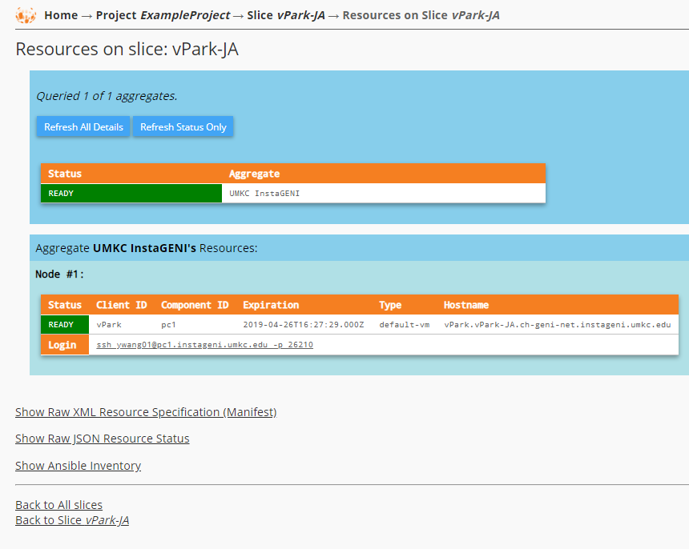

If you are having trouble finding this information, please refer back to the tutorial called Setup-Lab.

We will need a client to connect to our GENI machine. For this tutorial we will be using PuTTY as our client. If you don’t already have PuTTY, feel free to download it now from this link:

<https://www.chiark.greenend.org.uk/~sgtatham/putty/latest.html>

To use PuTTY with the GENI infrastructure we will need to generate a PuTTY private Key. This is done through the GENI Portal.

Click SSH Keys tab under your name which should be on the far right side of the page.

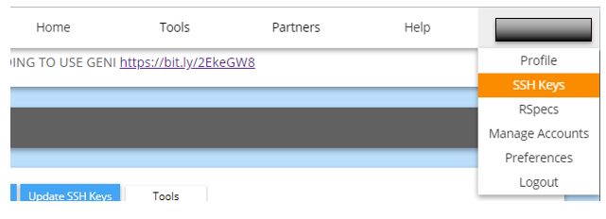

Now click the “Download PuTTY Key” button.

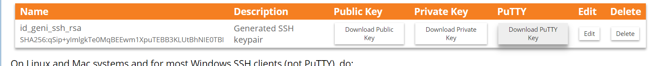

You must add a passphrase to your PuTTY key, make it something your can remember. Click the “Download PuTTY Key” button to make get your key. Keep it in a safe place on your Windows Host. We will be using it in PuTTY very soon.

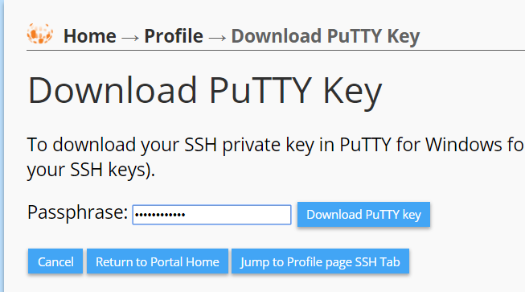

If you forgot the passphrase in the future, not to worry. All you have to do is make another PuTTY key.

Open the PuTTY Client on your Windows Host. We will be configuring a terminal session that also acts as a tunnel for our VNC connection to our GENI machine.

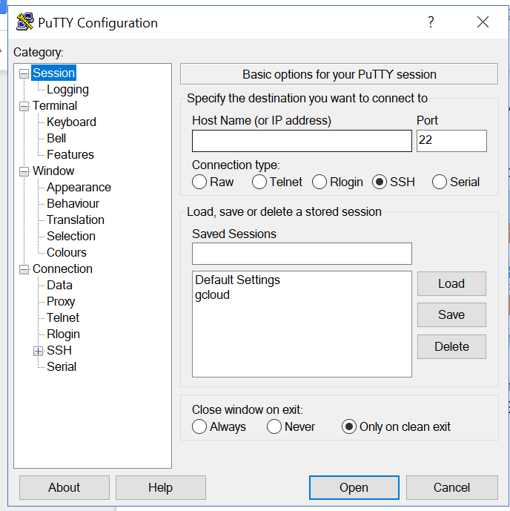

Notice the Category tabs on the left side display different setting that can be changed to make our connection. First we will configure the Session tab with our GENI URI and port number.

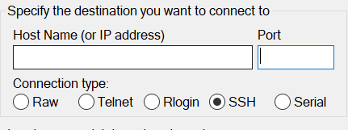

To get this information, go back to the URI information on the GENI Portal:



The login commands listed here are used to connect to GENI through a SSH client. We will need to copy specific pieces of it into the hostname and port fields in the PuTTy Session tab. Let us break it into pieces: ssh [ywang01@pc1.instageni.umkc.ed](mailto:ywang01@pc1.instageni.umkc.edu)u -p 26210

We need to copy [ywang01@pc1.instageni.umkc.ed](mailto:ywang01@pc1.instageni.umkc.edu)u portion into the field called Hostname field on the Session Tab. Next we need to copy 26210 into the Port field of the Session tab. These two fields should now look like this.

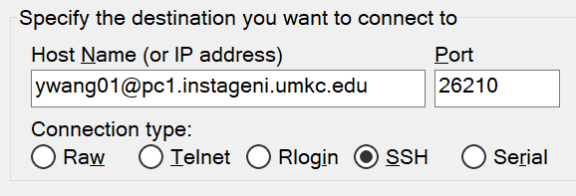

Now we need to configure PuTTY to use our PuTTY Private Key we generated earlier in this tutorial. To do this look at the panel on the left side of PuTTY. Towards the bottom you will see a tab called “Connection”. Expanding “Connection” will show another set of tabs. We are looking for the one called “SSH”. Expanding SSH will show more tabs. We are looking for the tab called Auth. Do not expand Auth, just click or highlight it to enter the Auth menu on the right.

[PuTTY -> Connection -> SSH -> Auth -> Browse]

Click Browse to find the location of the PuTTY Private Key we generated earlier. Make sure it is selected in the Auth tab like below:

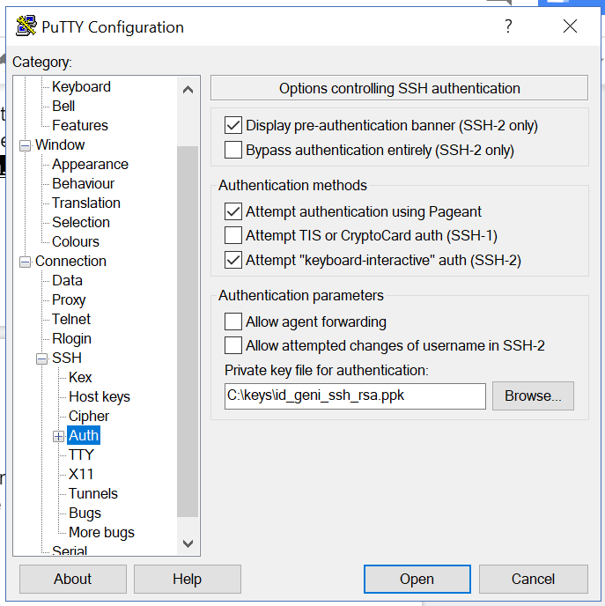

Since we are trying to make a tunnel for our VNC client to connect through, we will require a few additional configurations to make our PuTTY connection.

Navigate near the Auth tab on the left side, but move down one position to the X11 tab.

[PuTTY -> Connection -> SSH -> X11 ]

Make sure the “Enable X11 forwarding” box is checked like below.

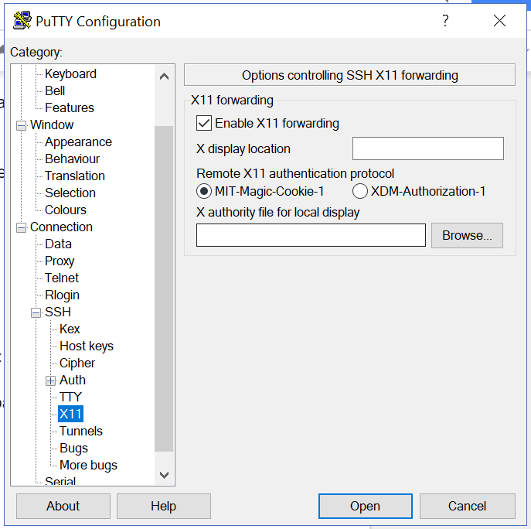

Next we will set up the tunnel used for our port forwarding. Move from the X11 tab to the Tunnels tab. [PuTTY -> Connection -> SSH -> Tunnels ]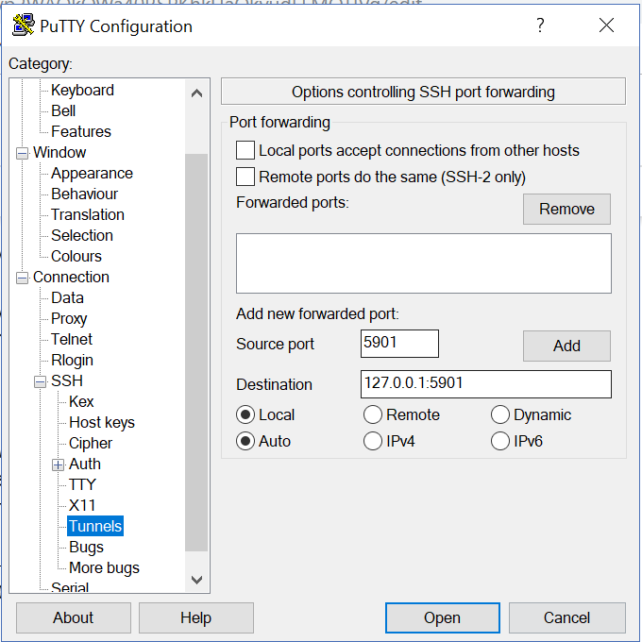

In the picture above, where you see Source Port field in the middle of the menu. Input 5901.

In the Destination field directly below the Source Port field, input 127.0.0.1:5901.

Click the Add button to save the port to forward in the tunnel. We are ready to make our connection.

Click the “Open” button at the bottom of PuTTY to initiate our connection to the GENI machine.

In your first log in, you will see a warning message below, simply click Yes button.

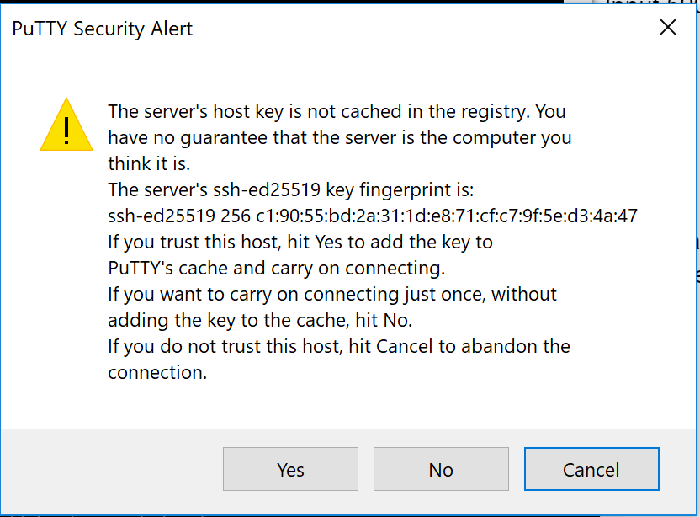

You will be prompted for the passphrase used when you generated your PuTTY Key. Entering this successfully, you will be greeted by a terminal connection on our GENI Machine.

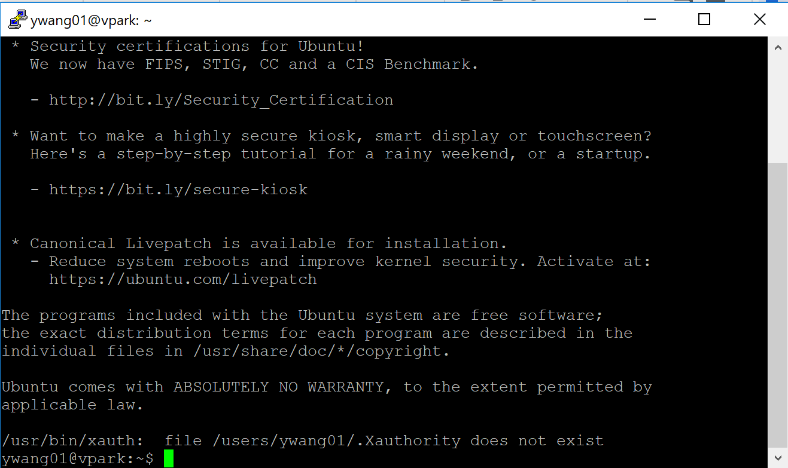

Now you have a Command Line Interface of the virtual machine on GENI, and we have established a tunnel connection for our VNC Client to connect through.

The next steps guide you to obtain a GUI.

**Step 2: Start VNC server on the GENI machine**

Next we will issue this command to start the VNC server:

vncserver

You should be prompted to enter in a password for your server. Enter in the password you’d like to use, choose “n” to the read-only password option, and hit Enter.

You should see some output in the PuTTY terminal like the picture below:

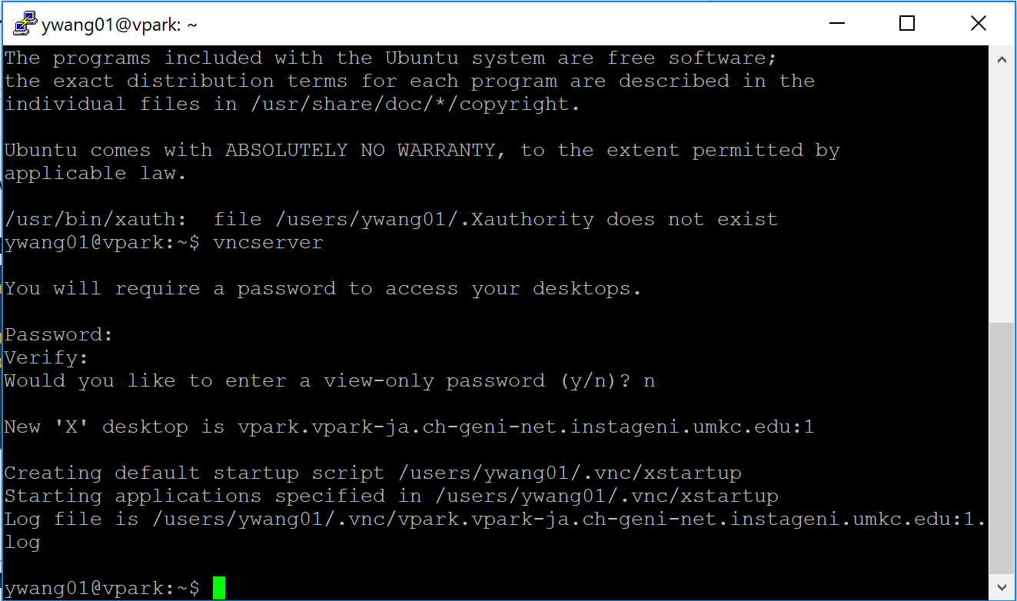

This indicates that our VNC server is up and running, and is ready for us to connect.

**Step 3: Install a VNC client on our Host machine**

Next we need to get a VNC client on to our host machine to connect to our new VNC server we just made. We recommend VNC Viewer which can be found at this link:

<https://www.realvnc.com/en/connect/download/viewer/>

All of the default settings should be fine. Agree to the EULA agreement, and Install. If your system does not allow you to install software, simply select “Standalone EXE” to download the non-install version.

**Step 4: Connect to the VNC server on the GENI machine.**

Open up the VNC Viewer program. Near the top is a input field to enter the location of our PuTTY tunnel. Since we binded this tunnel to 127.0.0.1:5901, we should be able to type “localhost:5901”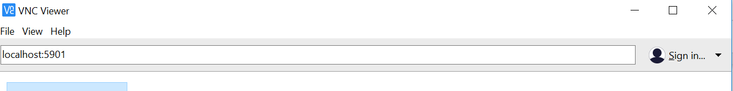

Clicking enter will initiate this connection. You may be presented with a warning about encryption. Just click through it. You will have to enter the VNC server password that we set up in Step 2. If successful, you will now be presented with your new GUI interface. **SELECT “Use default config” AT THE PROMPT WHEN YOU LOGIN.**

Take a look around. You now have access to a graphic web browser as well as a terminal program. Now your environment has the best of both worlds.

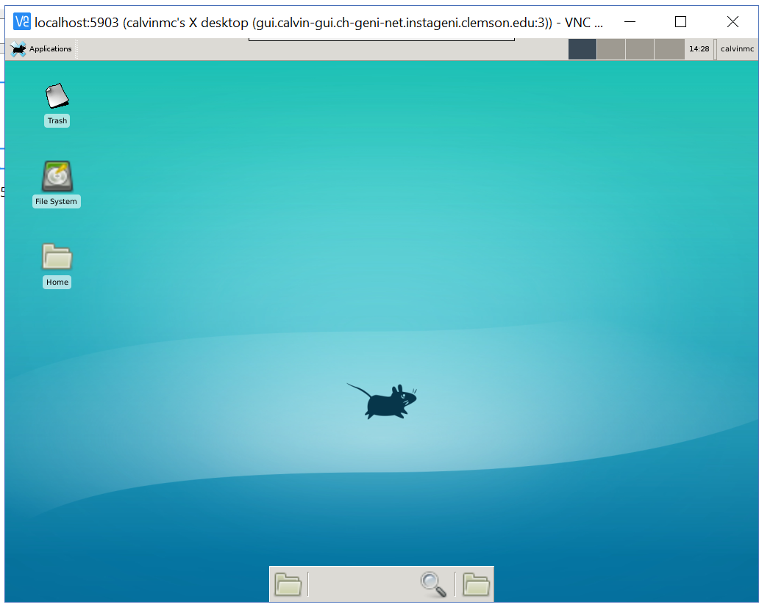

**For Mac/Linux Machine:**

You should already store your virtual machine private key (**id_geni_ssh_rsa**) to ~/.ssh/ directory. If you haven’t, you should complete the steps in Setup-User document, especially the section in the box that starts with “Alternatively, ...” (step 4 in that document ).

Suppose the connection details of a virtual machine is listed as follows. Notice the client id is displaying *victim*, which is the name of the virtual machines in the Lab.

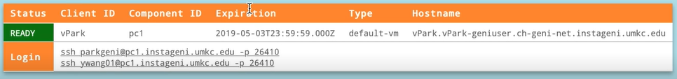

To provide the GUI and CLI on the GENI machine, we will be using Terminal and **Virtual Network Computing**, or **VNC**. Here is an overview of the steps.

**Key steps:**

1. Connect to GENI Machine with ssh command.
2. Run VNC Server on our GENI machine.
3. Install a VNC client on our Host machine
4. Connect to the VNC server on the GENI machine.

Let’s begin:

**Step 1: Connect GENI machine on Terminal**

Each ssh line listed, corresponds to a particular username. This can be seen on the right side of the ssh command. Highlight your ssh line, and copy (ctrl+c). Now go to the terminal running on your machine, paste this line into the terminal (ctrl+v). Now you need to insert option “-i <path_to_private_key>” after “ssh”.

For instance, if you are the user parkgeni, you should copy the ssh command “ssh parkgeni@pc1.instageni.umkc.edu -p 26410” and insert “-i” option to the command

Since you are trying to make a tunnel for our VNC client to connect through, you will require a few additional configurations on your Mac/Linux machine.

Add your VNC port number, which is is 5901. The change is show below:

*ssh -i <path_to_private_key>* ***-L 5901:127.0.0.1:5901 -N -f -l*** *<user name> <vm name> -p <vm port number>*

For instance, suppose you store your ssh keys in ~/.ssh/id_geni_ssh_rsa, and your connection information is as follows:



you should issue the command

***ssh -i ~/.ssh/id_geni_ssh_rsa -L 5901:127.0.0.1:5901 -N -f -l parkgeni pc1.instageni.umkc.edu -p 26410***

You will be prompted to enter passphrase for key ~/.ssh/id_geni_ssh_rsa. ’, then you should be able to input your passphrase for your ssh key if you provided one in the setup.

If your ssh connection is successful, you will see a screen like the one below:

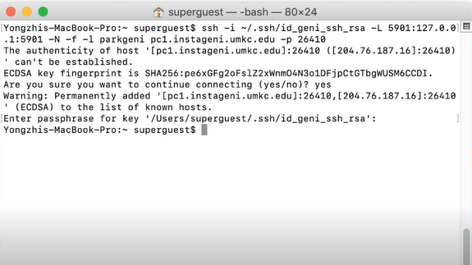

Now you will need to open a regular ssh connection to your GENI machine. Paste the information you copied earlier back into your terminal, and add in the path to your private key. For example, if you were user parkgeni, your command would be:

***ssh -i ~/.ssh/id_geni_ssh_rsa parkgeni@pc1.instageni.umkc.edu -p 26410***

Press Return, then you should be able to enter your private key password and be presented with a screen like this:

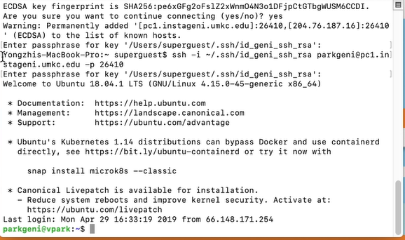

Note the green **parkgeni@vpark** text where our username was previously. This indicates that we are now logged into our GENI machine as our GENI user.

**Step 2: Start VNC server on the GENI machine**

Next we will issue this command to start the VNC server:

vncserver

You should see some output in the terminal like the picture below. It should ask you for the password that is used to connect to the VNC server later. For clarity, we call this password as *VNC password.* Remember the VNC password. You will use it later.



**Step 4: Install a VNC client on our Host machine**

Next we need to get a VNC client on to our host machine to connect to our new VNC server we just made. We recommend VNC Viewer which can be found at this link:

<https://www.realvnc.com/en/connect/download/viewer/>

**Step 5: Connect to the VNC server on the GENI machine.**

Open up the VNC Viewer program. Near the top is a input field to enter the location of our PuTTY tunnel. Since we binded this tunnel to 127.0.0.1:5901, we should be able to type “localhost:5901” 

Clicking enter will initiate this connection. You may be presented with a warning about encryption. Just click through it. You will have to enter the VNC server password that we set up in Step 2. If successful, you will now be presented with your new GUI interface. **SELECT “Use default config” WHEN PROMPTED AFTER CONNECTING TO YOUR GUI**.

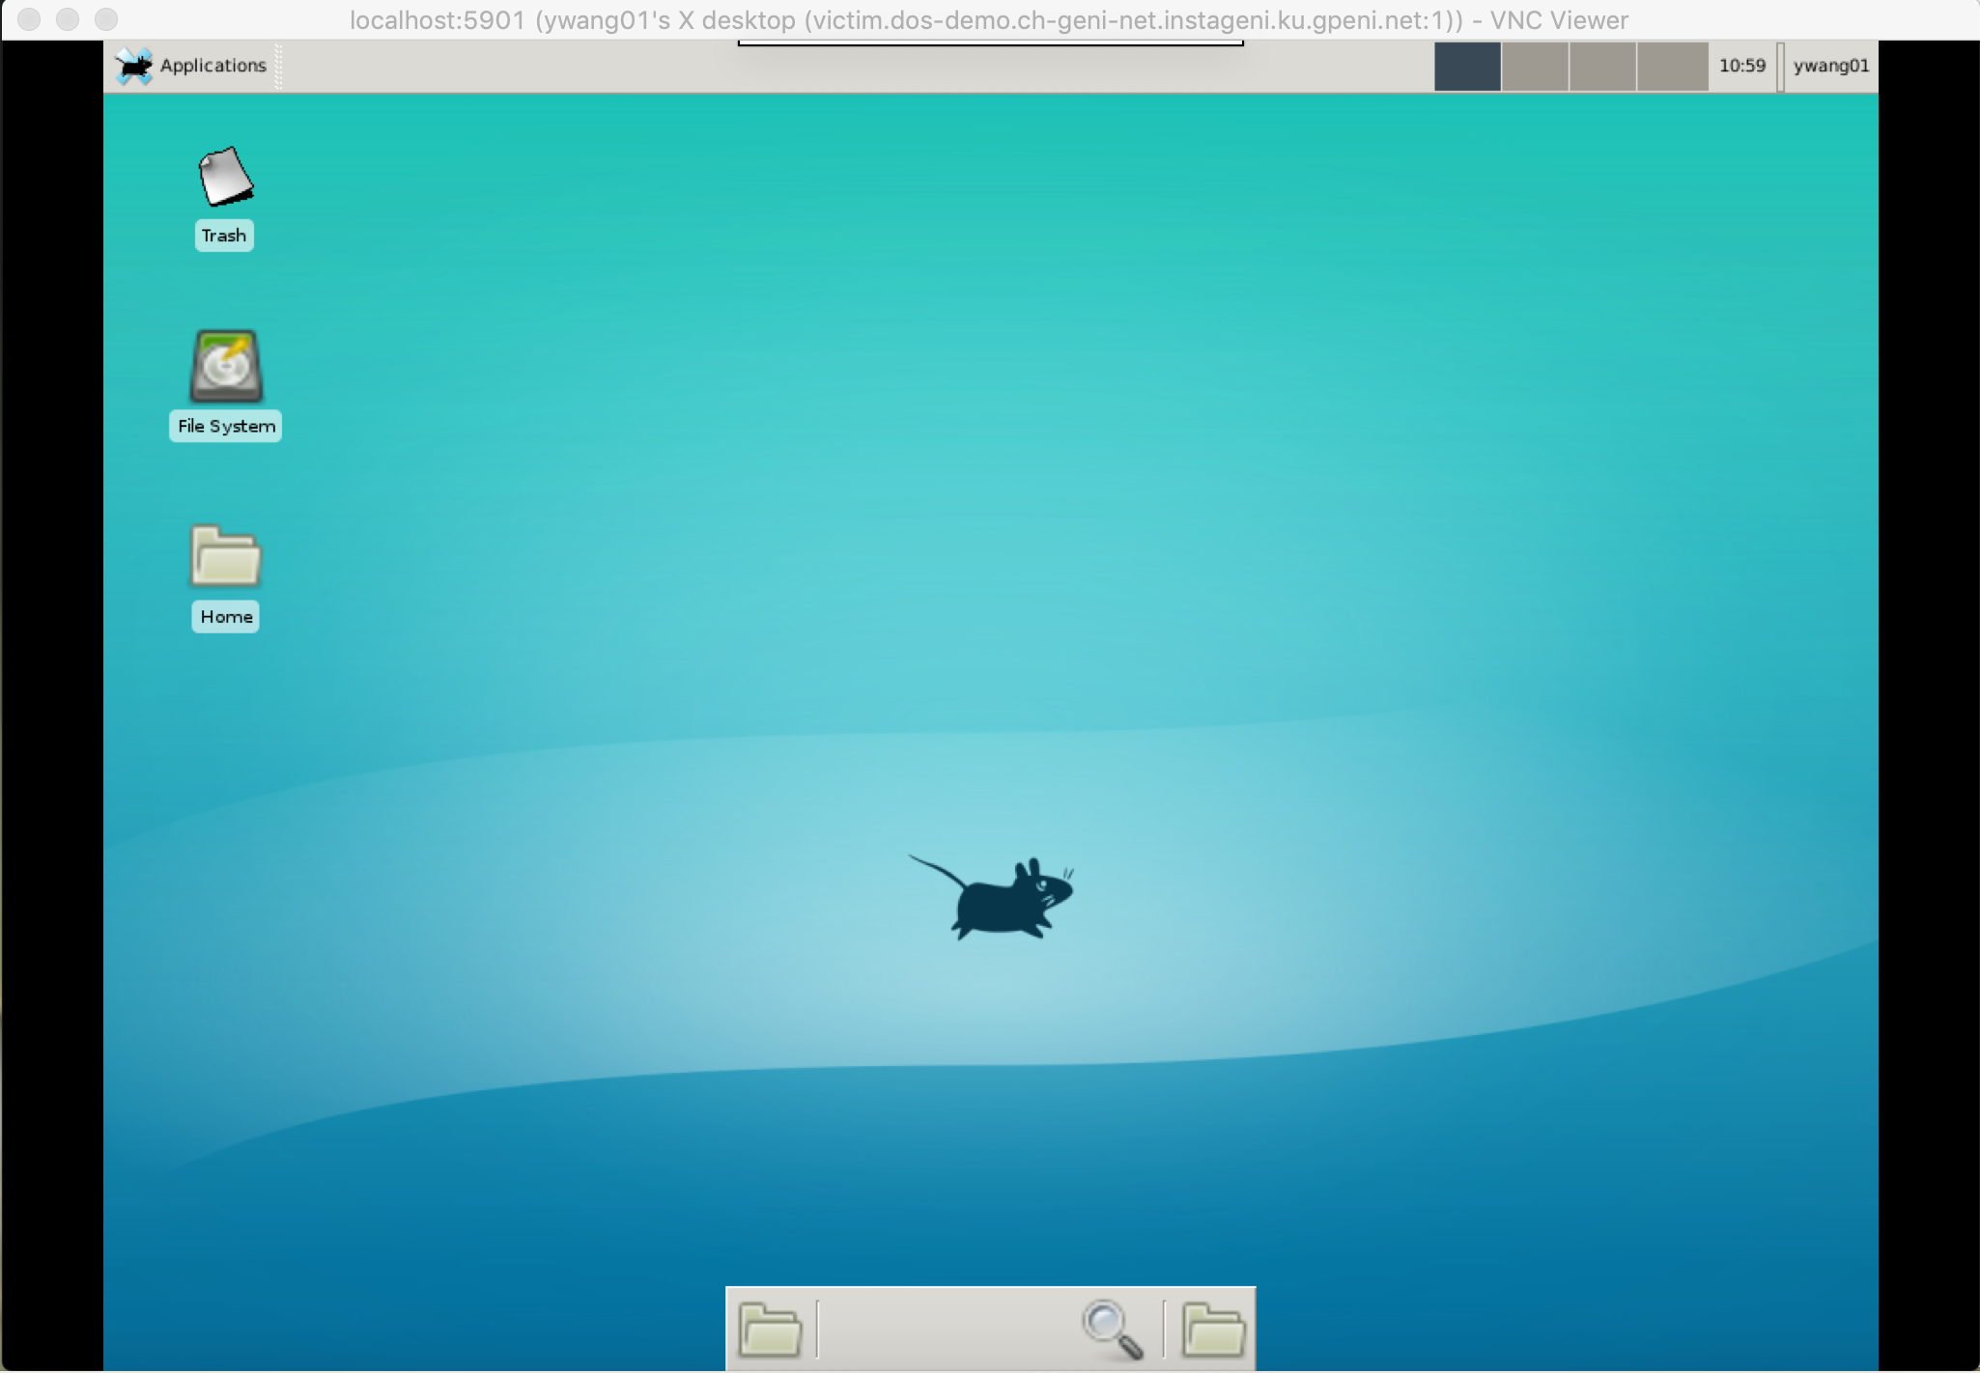

Take a look around. You now have access to a graphic web browser as well as a terminal program. Now your environment has the best of both worlds.

If you have any questions about vPark, please refer to the vPark FAQ document. The document contains pictures and steps to answer questions like “How to I extend the lifetime of my slice resources?” and “How do I download and upload documents to my GENI machine?” If your question is not answered by the FAQ document, please refer your question to your instructor.